Cover letter

Title:
Names of authors:
1.
2.
3.
4.
Affiliated institutions of all authors:
1.
2.
3.
4.
Correspondence details of all authors (including email addresses):
1.
2.
3.
4.
Note the corresponding author (in the case of more than one co-author):

Number of figures:
Number of tables:
Number of words:
(Do not include the word count from tables and the references section.)

What is the secondary language of this article?
If this language has regional variants, which regional variation is used in this article?

I confirm the following:
• this manuscript has not been published before and is not under consideration for publication elsewhere.
• the names of all the co-authors have been included in the manuscript and these co-authors all had an active part in the final manuscript, approved the manuscript and agree with its submission.
• all of the research presented in and connected with this study meets the ethical guidelines, including adherence to legal requirements, of the study country.
• I have received written permission from all persons mentioned in personal communications and acknowledgments.
• I have received written permission to reproduce any copyright materials (text, images, data or otherwise) which appear within this manuscript.

NOTE:
In cases where materials under copyright have been used in the manuscript, please contact the editor for further instructions.

The title goes here: The secondary title goes here

Primary Author Name ¹, Secondary Author ², Secondary Author ³
1. Institutional affiliation. Contact address. Email: email@address.com
2. Institutional affiliation. Contact address. Email: email@address.com
3. Institutional affiliation. Contact address. Email: email@address.com

Abstract:
The regular abstract goes here

Keywords: five to eight key words go here, separated by semi-colons

1. Introduction and background
The introduction section text goes here.

1.1. Sub-section (part of the introduction)
Text goes here.

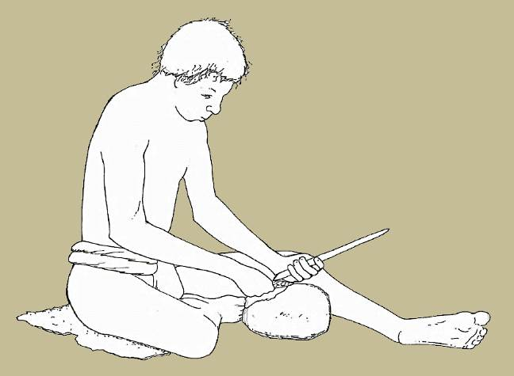
Figure 1. The caption for the figure goes here.
Figure 1. The translated caption for the figure goes here. (Translate also the word “figure”.)

1.2. Sub-section (part of the introduction)
Text goes here.

2. Methods
Text goes here.

2.1. Sub-section (part of the methods section)
Text goes here.

Table 1. The table caption goes here.
Table 1. The translated table caption goes here. (Translate also the word “table”.)
Column 1 | Column 2 | Column 3 | Last column
data | data | data | data
data | data | data | data
data | data | data | data

2.2. Sub-section (part of the methods section)
Text goes here.

2.2.1. Sub-sub-section (part of sub-section 2.2)
Text goes here.

2.2.2. Sub-sub-section (part of sub-section 2.2)
Text goes here.

3. Data results
Text goes here.

Table 2. The table caption goes here.
Table 2. The translated table caption goes here. (Translate also the word “table”.)
Column 1 | Column 2 | Column 3 | Last column
data | data | data | data
data | data | data | data
data | data | data | data

4. Interpretations of the data
Text goes here.

5. Conclusions, significance, opinions
Text goes here.

Acknowledgements
Text goes here.

References
Place all references cited in the text at the end of the article. See the instructions file for information on how to format references. If you use EndNote, please use the designated EndNote style sheet for the journal (J Lithic St). EndNote will automatically generate a bibliography section here, with references in the correct formats.
As in regular articles, references which are not in English should include a translation of the title into English. They may also have a second translation of the title into the secondary language of the article. Additionally, references which are in English should include a translation of the title into the secondary language of this article.

Translated title goes here: The secondary title goes here
Primary Author Name ¹, Secondary Author ², Secondary Author ³ (in original alphabet)
1. Institutional affiliation. Contact address. Email: email@address.com
2. Institutional affiliation. Contact address. Email: email@address.com
3. Institutional affiliation. Contact address. Email: email@address.com

Abstract:
The translated extended abstract goes here. Note that this abstract should be between 500 and 1000 words. It must follow same format as the article but have no headings. It must also mention methodology, overview of results, and conclusions.

Keywords: translated key words go here, separated by semi-colons

Please translate the following sentences into the secondary language of the article.

(For higher resolution images, see the supplemental files.)
TRANSLATION:

(View a higher resolution version of this image.)
TRANSLATION:

(Download this file as an XLS spread sheet file.)
TRANSLATION:

