Cover letter

Title: Book review:
Review author:
(surname first, e.g. SMITH, John; GONZALES-HERNANDES, Rebeca)
Affiliated institution of the review author:
(include the city and country)
Email address of the author:

Cover image: (YES / NO)
Number of words:

Have you reviewed this book for another journal (whether published yet or not)? (YES / NO)
If so, please send us also a copy of the other review.

Palaeoindian Archaeology might publish a book review which the reviewer has already reviewed for another journal if the new review is significantly different from the previous one and either it is a general book of importance to palaeoindian researchers as a whole or the original review was published in a way which limits its dissemination (grey literature, small or regional publication, print only publication, in other language, self-published). The editors of the journal will decide on a case-by-case basis. If someone intends to review a book for us which they have already reviewed, they are advised to let us know about the situation before writing the review.

I confirm the following:
• this manuscript has not been published before and is not under consideration for publication elsewhere.
• I have received written permission from all persons mentioned in personal communications and acknowledgments.
• I have received written permission to reproduce any copyright materials (text, images, data or otherwise) which appear within this manuscript.

NOTE:
In cases where materials under copyright have been used in the manuscript, please contact the editor for further instructions.

Book review: The book title goes here

Review Author’s Name
Institutional affiliation. Contact address, City, Country. Email: email@address.com

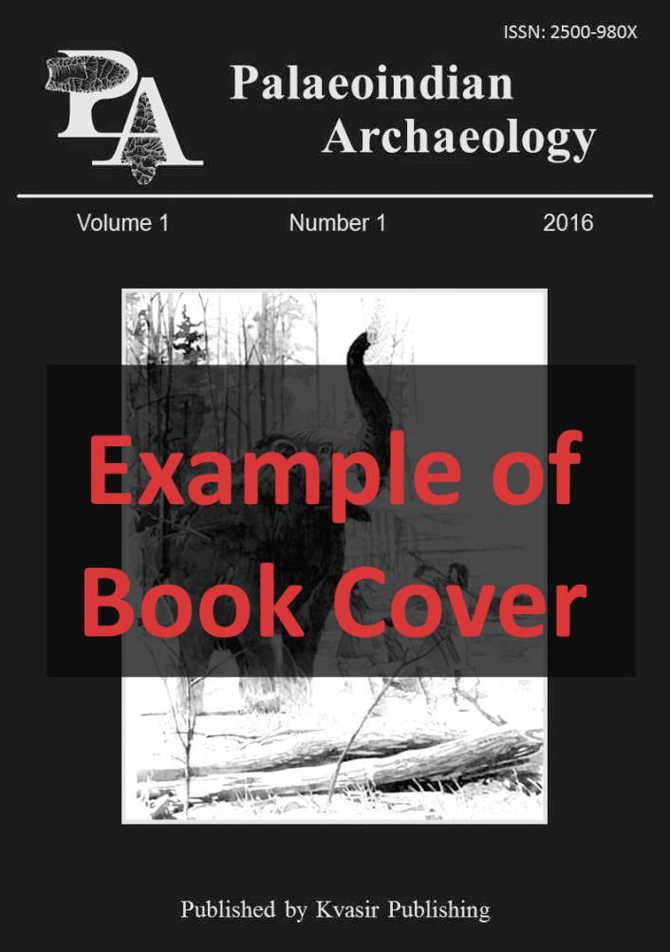

The title of the book goes here
by / edited by Sydney F. Carrere and Nigel B. Anholt
Trinity College Press, 2013, pp. 321, pl. 21. ISBN 978-973-703-758-9
Insert a link to the publisher’s website, in particular to the page where this book is presented.

The text of the book review goes here. There is no specific word limit for book reviews but 400 to 800 words is a good target to aim for. We recommend that you start off by introducing the book with an overall summary.
Book reviews should also include chapter summaries. Tell the reader the main topics of each chapter and possibly the highlights of some chapters. If not all chapters deal with palaeoindian studies then do not go into detail on such chapters.
The reviewer should note the highlights or special aspects of this book, in particular those related to palaeoindian studies. We particularly encourage reviews of books that are not in English as this helps disseminate information that readers in some countries may not otherwise know about.

